Student number : ST10489610

Name: Miguel ian Masinga

BIT

WEB DEVELOPMENT POE PART 1

Lecturer: Mr Vilakazi

Contents

Website Development Proposal for Elegant Scents – Perfume and Cologne Company 3

Organisation overview 3

• Client Name: 3

Mission statement 3

Vision 3

Target audience 3

Website Goals and Objectives 3

Website Features and Functionality 3

Design and User Experience 4

Technical Requirements 4

Images Used 4

Timeline and Milestones 7

Budget 7

References 7

# Website Development Proposal for Elegant Scents – Perfume and Cologne Company

## Organisation overview

* Client Name: Elegant Scents
* Elegant Scents is a South African Based fragrance shop that is only focused on selling

Colognes, Perfumes and Perfume oils. It is located in Mpumalanga but can ship their products anywhere in South Africa.

### Mission statement

Elegant Scents aims to ensure that everyone smells good and feels confident every season of the year and at a very affordable price.

### Vision

Elegant Scents intends to have at least one store in each and every province in South Africa in the next 7 years to ensure that more people smell great and have a higher self esteem at a very affordable price.

### Target audience

Elegant scents targets individuals between the ages of 20-50 years of age, who just want to smell good when going to school, work or just going about their day

## Website Goals and Objectives

The primary goals and objectives of the website are to

* **Increase Online Sale**.
* **Responsive Design**.
* **Inform Customers**.

## Website Features and Functionality

The Elegant Scents website has the following features:

#### Home page

Consists of high quality pictures of featured products in order to grab the customers attention at first glance

#### About Us

Contains background information about the company as a whole, like when and where it was established

#### Products

Contains high quality images of some of the products sold on the website.

#### Contact

Contains various ways to get in touch with the company, whether to buy or if you want any additional information.

#### Enquiries

Contains information on what to do if you have want to be part of the Elegant Scents team

## Design and User Experience

* Colour scheme**:**

A simple black and white colour scheme without and bright colours for that easy on the eye feeling.

* Product images:

Extremely high quality, professional photos of the products which are very clear to see on any device.

## Technical Requirements

The website is created using visual studio code and the programming language used is HTML.

## Images Used

Harsh Limbachia**:** pexels

Mareefe :pexels

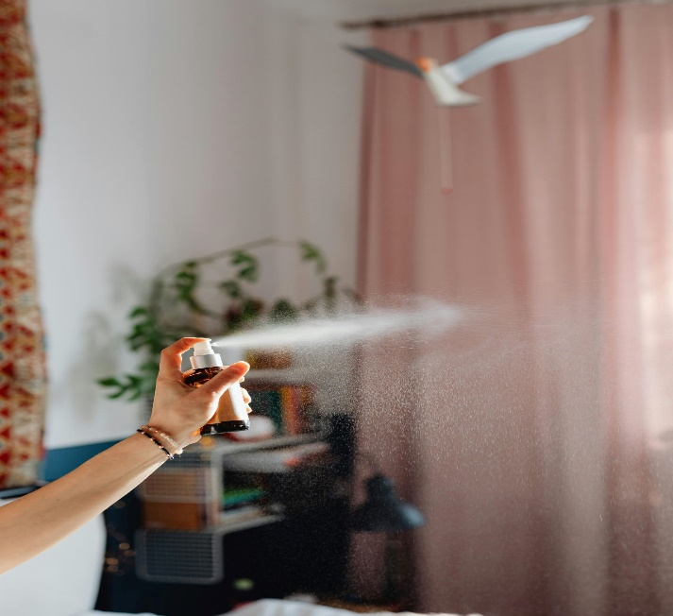

Kaboompics :pexels



Castorly Stock: pexels

Yusuf Arslan

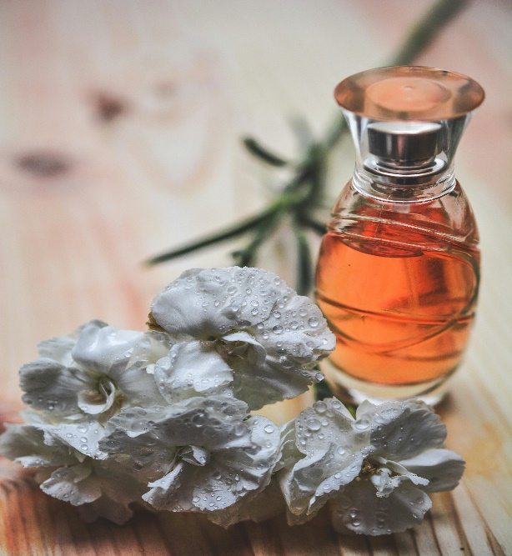

Pixabay: Pexels

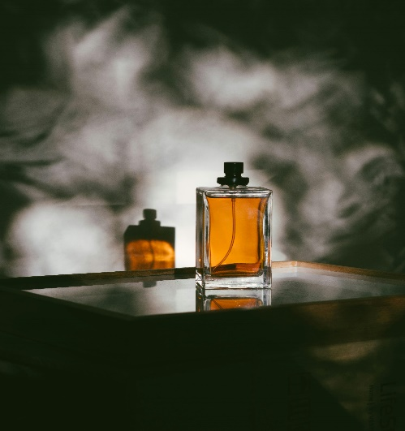

RF Studio: pexels

## Timeline and Milestones

* Initial consultation and design approval: 1 week
* Website Development (backend and front end): 4 weeks
* Testing and Quality Assurance: 1 week
* Launch and Post-Launch Support

## Budget

will be The budget for everything R2500, this includes hosting and maintenance

## References

* Harsh Limbachia <https://images.pexels.com/photos/11577068/pexels-photo-11577068.jpeg?auto=compress&cs=tinysrgb&w=600>
* Mareefe <https://images.pexels.com/photos/932577/pexels-photo-932577.jpeg?auto=compress&cs=tinysrgb&w=600>
* Kaboompics <https://images.pexels.com/photos/6633526/pexels-photo-6633526.jpeg?auto=compress&cs=tinysrgb&w=600>
* Castorly Stock <https://images.pexels.com/photos/3785784/pexels-photo-3785784.jpeg?auto=compress&cs=tinysrgb&w=600>
* Yusuf Arslan, <https://images.pexels.com/photos/3640668/pexels-photo-3640668.jpeg?auto=compress&cs=tinysrgb&w=600>
* Pixabay, <https://images.pexels.com/photos/264950/pexels-photo-264950.jpeg?auto=compress&cs=tinysrgb&w=600>
* RF Studio, <https://images.pexels.com/photos/3059609/pexels-photo-3059609.jpeg?auto=compress&cs=tinysrgb&w=1260&h=750&dpr=2>